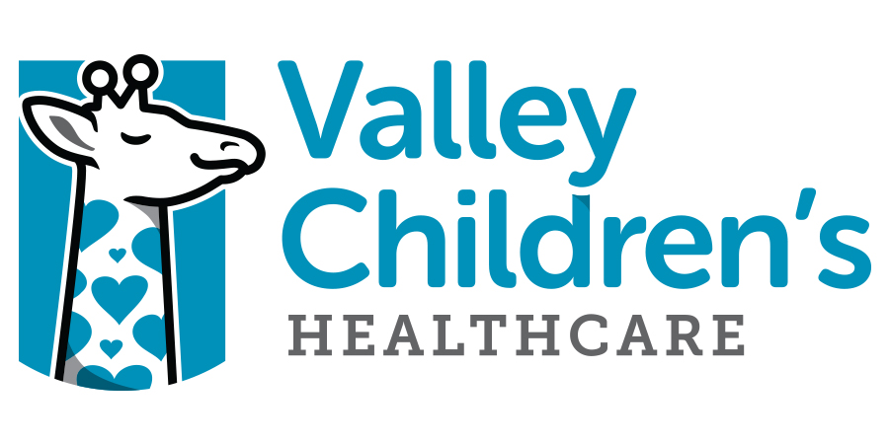

CONFIDENTIALITY AGREEMENT FOR NON-EMPLOYEES

I, the undersigned, acknowledge that during the course of my voluntary participation or performance of duties at Valley Children’s Healthcare that I may receive access to confidential information of Valley Children’s that is prohibited from disclosure to others.

“Confidential Information” means information provided by Valley Children’s that is not commonly available to the general public, or is required by law or regulation to be protected from disclosure to third parties not considered part of the Hospital’s “workforce” as that term is defined by federal and state health information privacy regulations such as the Health Information Portability and Accountability Act and the California Confidentiality of Medical Information Act. Confidential Information includes information contained in patient medical records and any other health information which identifies a patient; quality assurance, research or peer review information; and information concerning Valley Children’s employees, services or business operations. Such information can be acquired by any means and in any form, written, spoken or electronic.

I agree not to share, disclose or discuss Confidential Information with anyone who does not have a legitimate interest in such information. I will abide by Valley Children’s policies and procedures concerning the use or disclosure of Confidential Information and I will contact a Valley Children’s representative if I have any questions regarding these policies and procedures.

I will maintain and protect the privacy of Valley Children’s employees, medical staff and patients in my use and disclosure of Confidential Information and I will not misuse or be careless with such information.

I understand that any violation of this Agreement or Valley Children’s policies related to access, use or disclosure of Confidential Information may result in significant legal ramifications for which I will be held solely responsible with respect to this Agreement.

I acknowledge that I have reviewed all of the information above. I understand that compliance with the principles, policies and procedures expressed above is a condition of my participation and continued presence at Valley Children’s Healthcare.

_______________________________ __________________________
Name (please print) Date

__________________________________
Signature School

